**Supplementary Appendix A**

**Table of Contents**

**Figure A1. Summary description of model design.** 3

**Figure A2. Top twenty predictors of risk of death from cancer 12 to 24 months after diagnosis. Model of the top 5 causes of death, with Catboost Classifier.** 4

**Figure A3. Main predictors of risk of death from cancer between 12 and 24 months after diagnosis for three randomly selected individuals: a) high risk of death (true positive with 0.959 score), b) medium risk of death (false negative with 0.358 score) and c) low risk of death (true negative with 0.131 score), top 5 causes of death model with Catboost Classifier.** 4

**Figure A4. Top twenty predictors of risk of death from cancer 12 to 24 months after diagnosis. Model for bronchus and lung cancer, with Catboost Classifier.** 5

**Figure A5. Main predictors of risk of death from cancer between 12 and 24 months after diagnosis for three randomly selected individuals: a) high risk of death (true positive with 0.971 score), b) medium risk of death (false negative with 0.346 score) and c) low risk of death (true negative with 0.139 score), model for bronchus and lung cancer, with Catboost Classifier.** 5

**Figure A6. Top twenty predictors of risk of death from cancer 12 to 24 months after diagnosis. Model for breast cancer, with Catboost Classifier.** 6

**Figure A7. Main predictors of risk of death from cancer between 12 and 24 months after diagnosis for three randomly selected individuals: a) high risk of death (true positive with 0.971 score), b) medium risk of death (false negative with 0.346 score) and c) low risk of death (true negative with 0.139 score), model for breast cancer, with Catboost Classifier.** 6

**Figure A8. Top twenty predictors of risk of death from cancer 12 to 24 months after diagnosis. Model for stomach cancer, with Gradient Boosting Classifier.** 7

**Figure A9. Main predictors of risk of death from cancer between 12 and 24 months after diagnosis for three randomly selected individuals: a) high risk of death (true positive with 0.917 score), b) medium risk of death (true negative with 0.448 score) and c) low risk of death (false with 0.057 score), model for stomach cancer, with Gradient Boosting Classifier.** 7

**Figure A10. Top twenty predictors of risk of death from cancer 12 to 24 months after diagnosis. Model for colon cancer, with Catboost Classifier.** 8

**Figure A11. Main predictors of risk of death from cancer between 12 and 24 months after diagnosis for three randomly selected individuals: a) high risk of death (true positive with 0.885 score), b) medium risk of death (true negative with 0.431 score) and c) low risk of death (true negative with 0.104 score), model for colon cancer, with Catboost Classifier.** 8

**Figure A12. Top twenty predictors of risk of death from cancer 12 to 24 months after diagnosis. Model for rectum cancer, with Catboost Classifier.** 9

**Figure A13. Main predictors of risk of death from cancer between 12 and 24 months after diagnosis for three randomly selected individuals: a) high risk of death (true positive with 0.929 score), b) medium risk of death (false positive with 0.672 score) and c) low risk of death (true negative with 0.165 score), model for rectum cancer, with Catboost Classifier.** 9

**Figure A14. Top twenty predictors of risk of death from cancer 12 to 24 months after diagnosis. Model for prostate cancer, with Catboost Classifier.** 10

**Figure A15. Main predictors of risk of death from cancer between 12 and 24 months after diagnosis for three randomly selected individuals: a) high risk of death (true positive with 0.707 score), b) medium risk of death (true positive with 0.560 score) and c) low risk of death (true negative with 0.033 score), model for prostate cancer, with Catboost Classifier.** 10

**Figure A16. Top twenty predictors of risk of death from cancer 12 to 24 months after diagnosis. Model for cervix uteri cancer, with Catboost Classifier.** 11

**Figure A17. Main predictors of risk of death from cancer between 12 and 24 months after diagnosis for three randomly selected individuals: a) high risk of death (true positive with 0.939 score), b) medium risk of death (true negative with 0.470 score) and c) low risk of death (true negative with 0.118 score), model for cervix uteri cancer, with Catboost Classifier.** 11

# **Figure A1. Summary description of model design.**

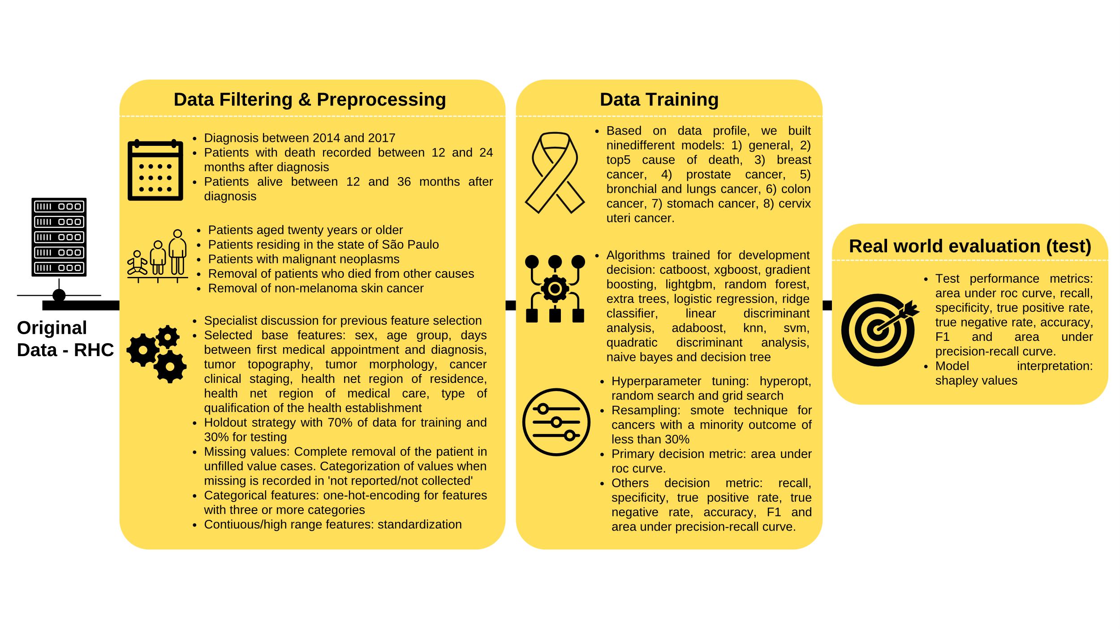

# **Figure A2. Top twenty predictors of risk of death from cancer 12 to 24 months after diagnosis. Model of the top 5 causes of death, with Catboost Classifier.**

# **Figure A3. Main predictors of risk of death from cancer between 12 and 24 months after diagnosis for three randomly selected individuals: a) high risk of death (true positive with 0.959 score), b) medium risk of death (false negative with 0.358 score) and c) low risk of death (true negative with 0.131 score), top 5 causes of death model with Catboost Classifier.**

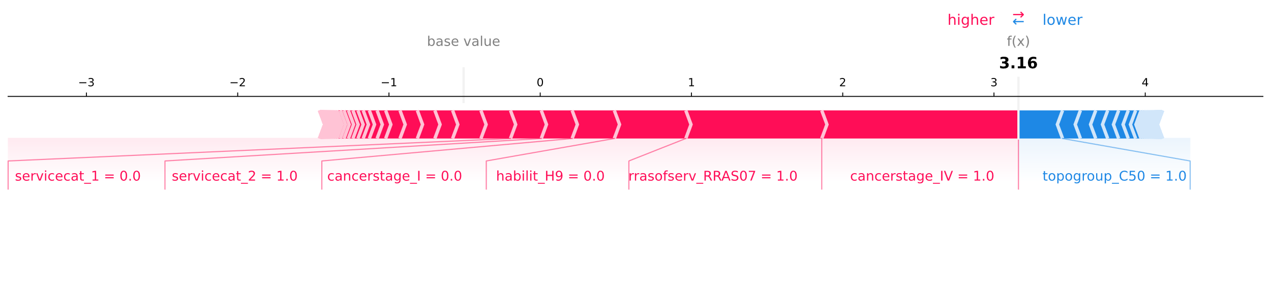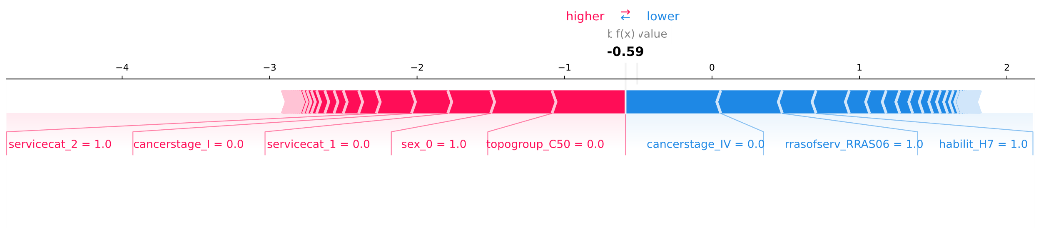

**a**

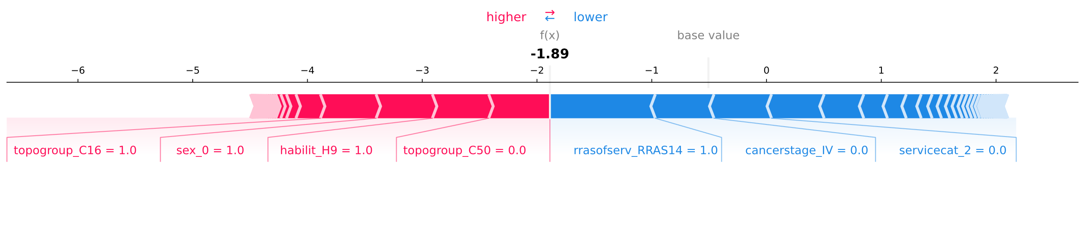

**c**

**b**

# **Figure A4. Top twenty predictors of risk of death from cancer 12 to 24 months after diagnosis. Model for bronchus and lung cancer, with Catboost Classifier.**

# **Figure A5. Main predictors of risk of death from cancer between 12 and 24 months after diagnosis for three randomly selected individuals: a) high risk of death (true positive with 0.971 score), b) medium risk of death (false negative with 0.346 score) and c) low risk of death (true negative with 0.139 score), model for bronchus and lung cancer, with Catboost Classifier.**

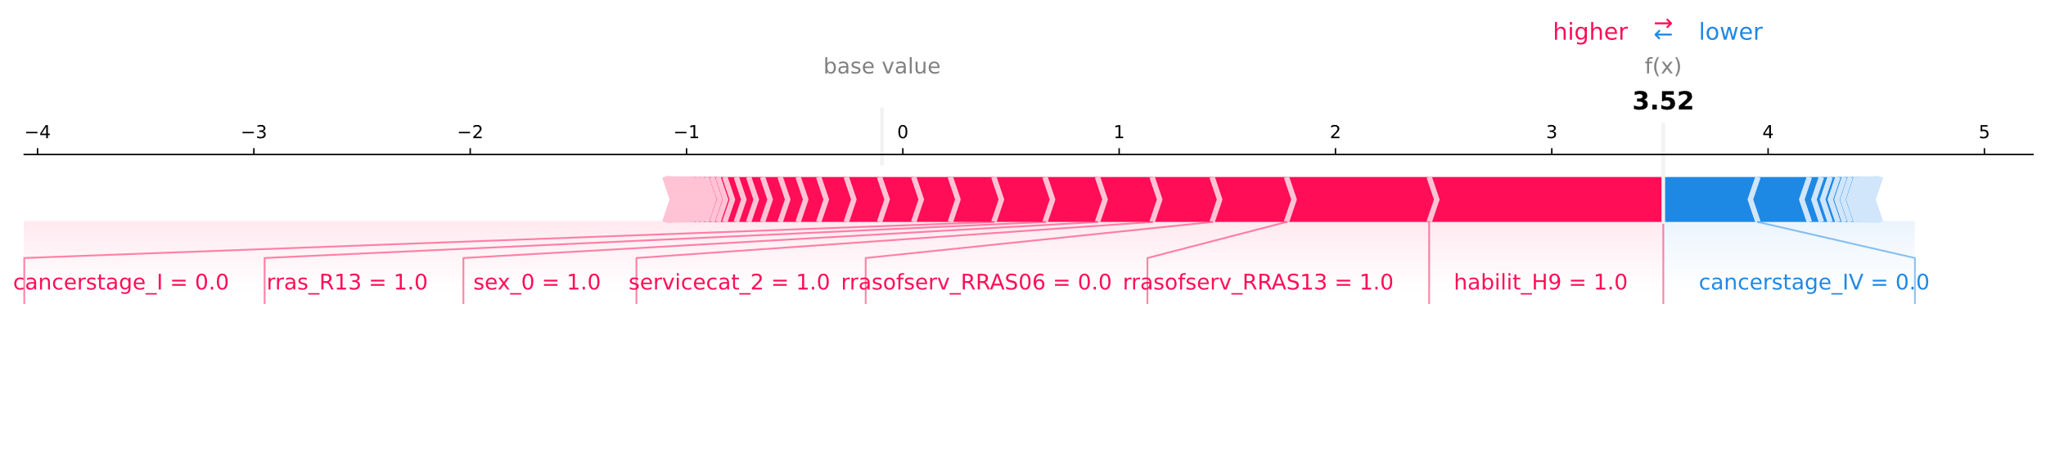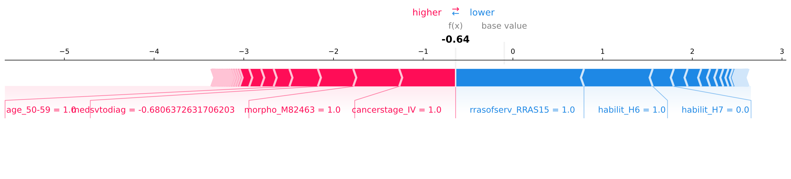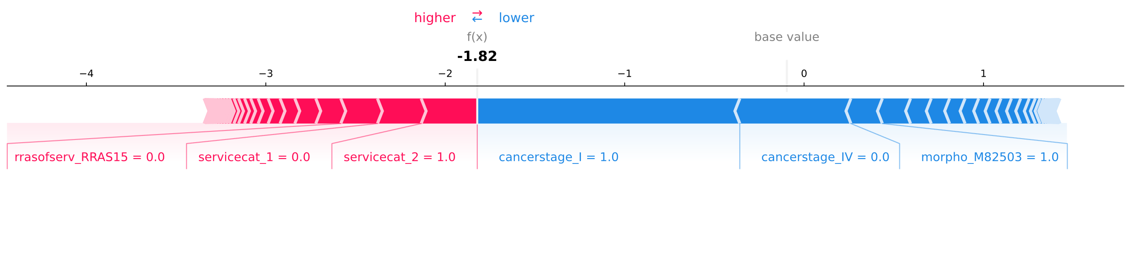

**a**

**b**

**c**

# **Figure A6. Top twenty predictors of risk of death from cancer 12 to 24 months after diagnosis. Model for breast cancer, with Catboost Classifier.**

# **Figure A7. Main predictors of risk of death from cancer between 12 and 24 months after diagnosis for three randomly selected individuals: a) high risk of death (true positive with 0.971 score), b) medium risk of death (false negative with 0.346 score) and c) low risk of death (true negative with 0.139 score), model for breast cancer, with Catboost Classifier.**

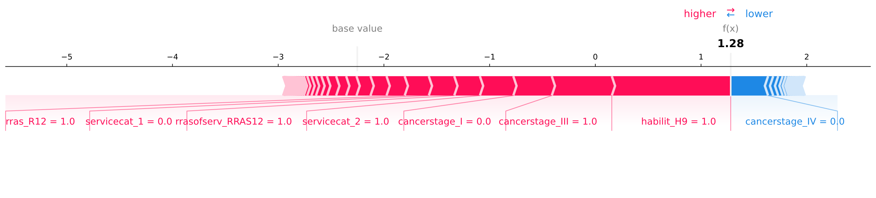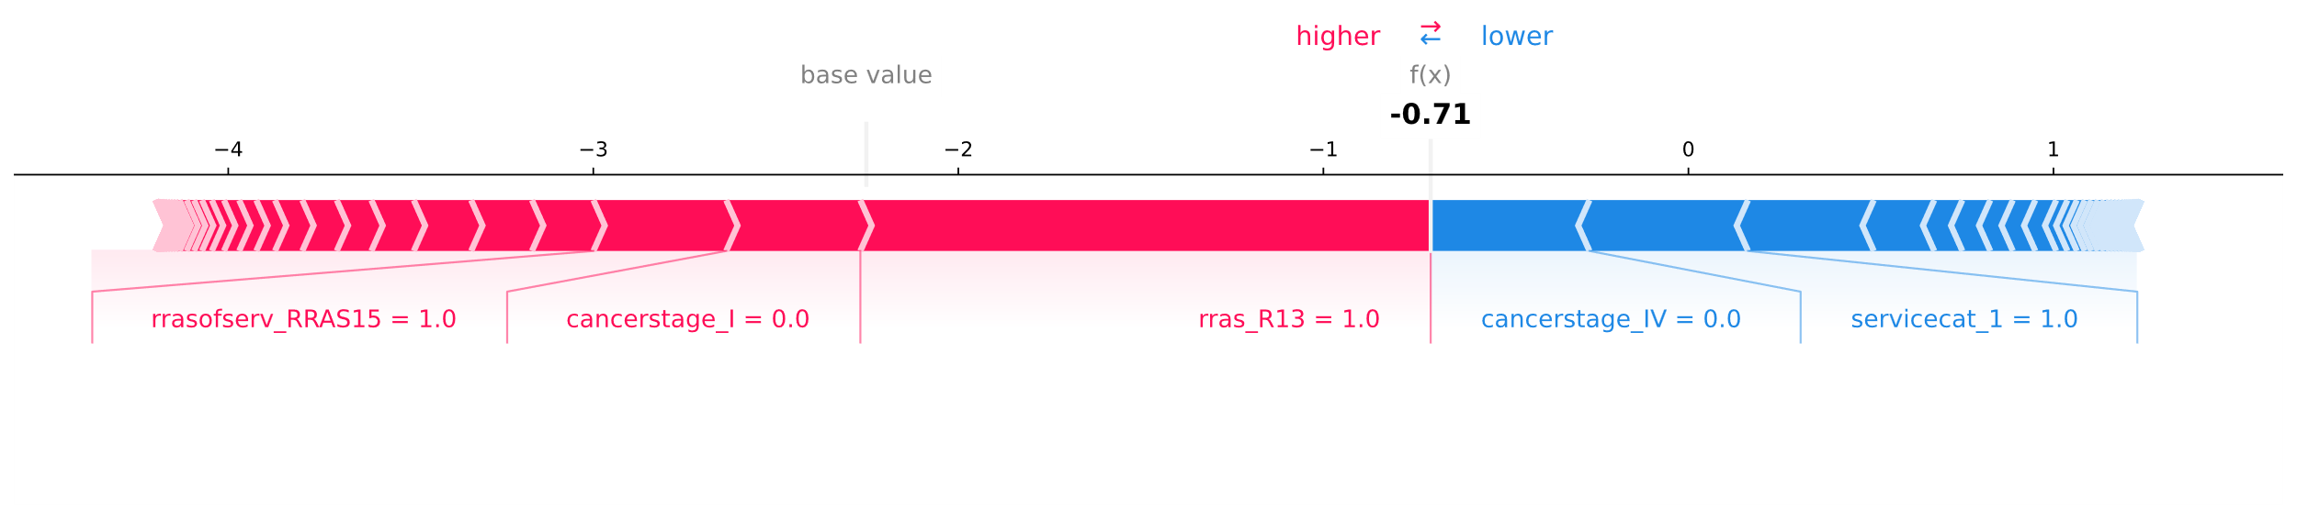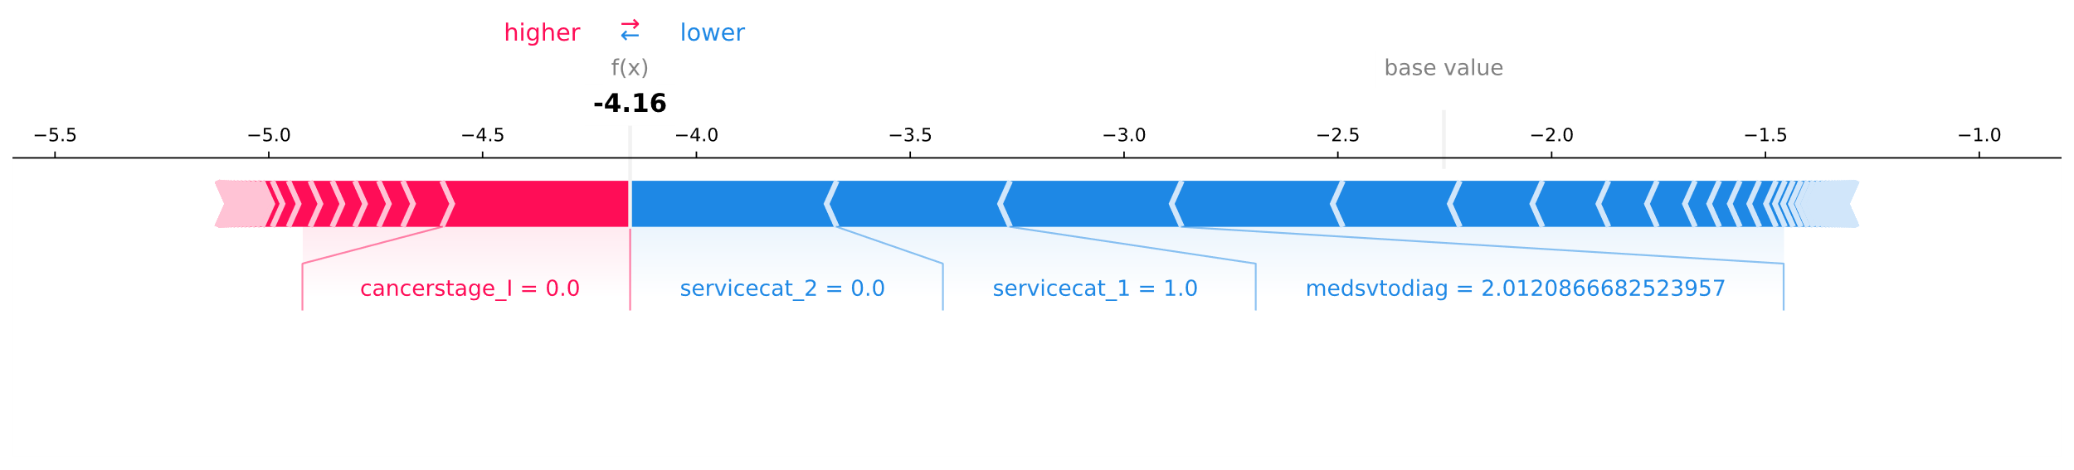

**a**

**b**

**c**

# **Uma imagem contendo Gráfico Descrição gerada automaticamenteFigure A8. Top twenty predictors of risk of death from cancer 12 to 24 months after diagnosis. Model for stomach cancer, with Gradient Boosting Classifier.**

# **Figure A9. Main predictors of risk of death from cancer between 12 and 24 months after diagnosis for three randomly selected individuals: a) high risk of death (true positive with 0.917 score), b) medium risk of death (true negative with 0.448 score) and c) low risk of death (false with 0.057 score), model for stomach cancer, with Gradient Boosting Classifier.**

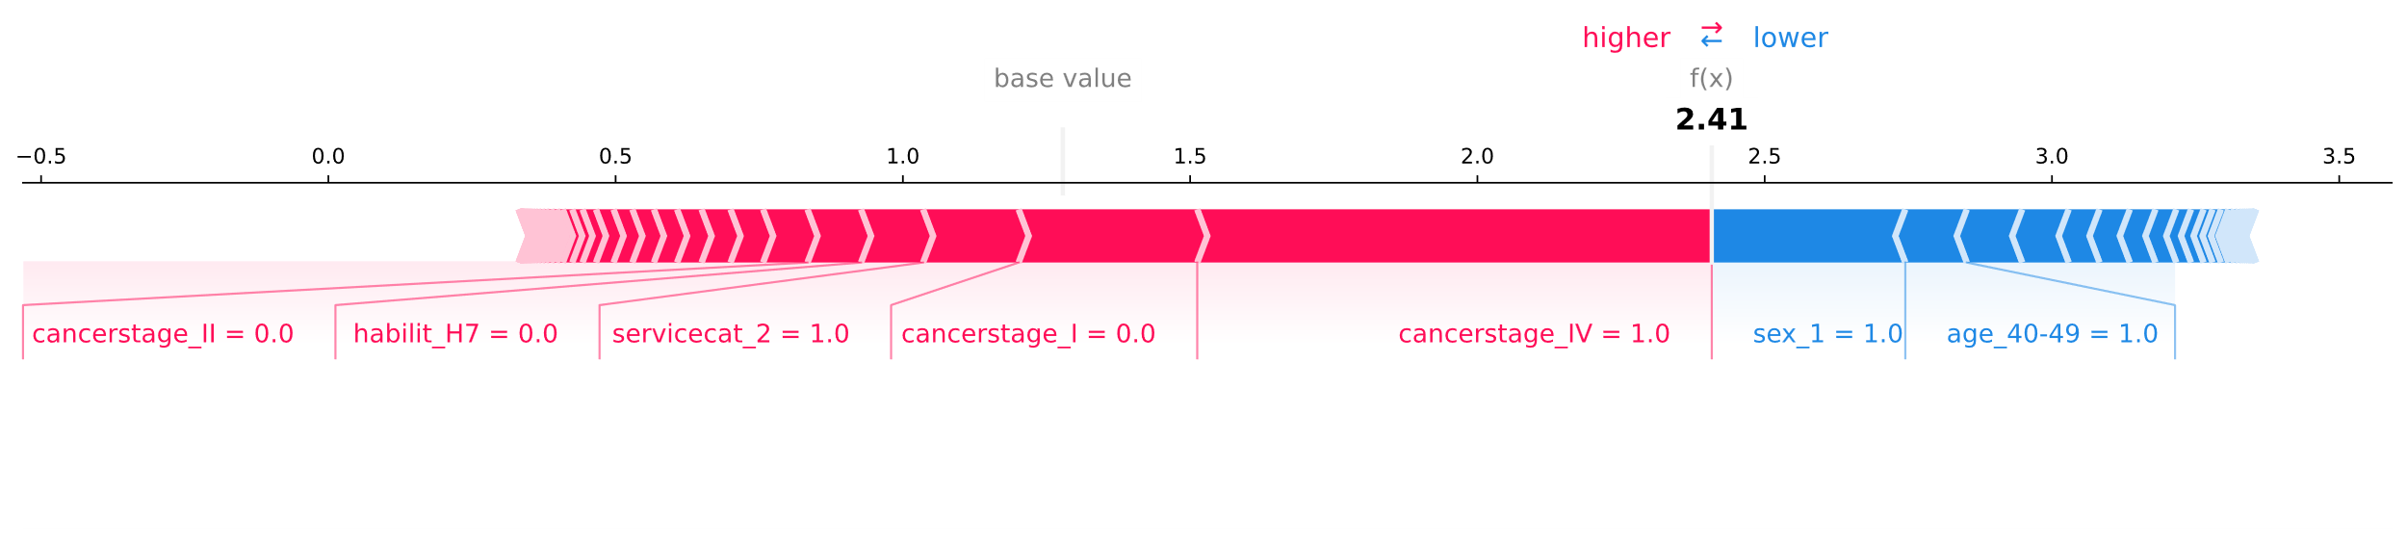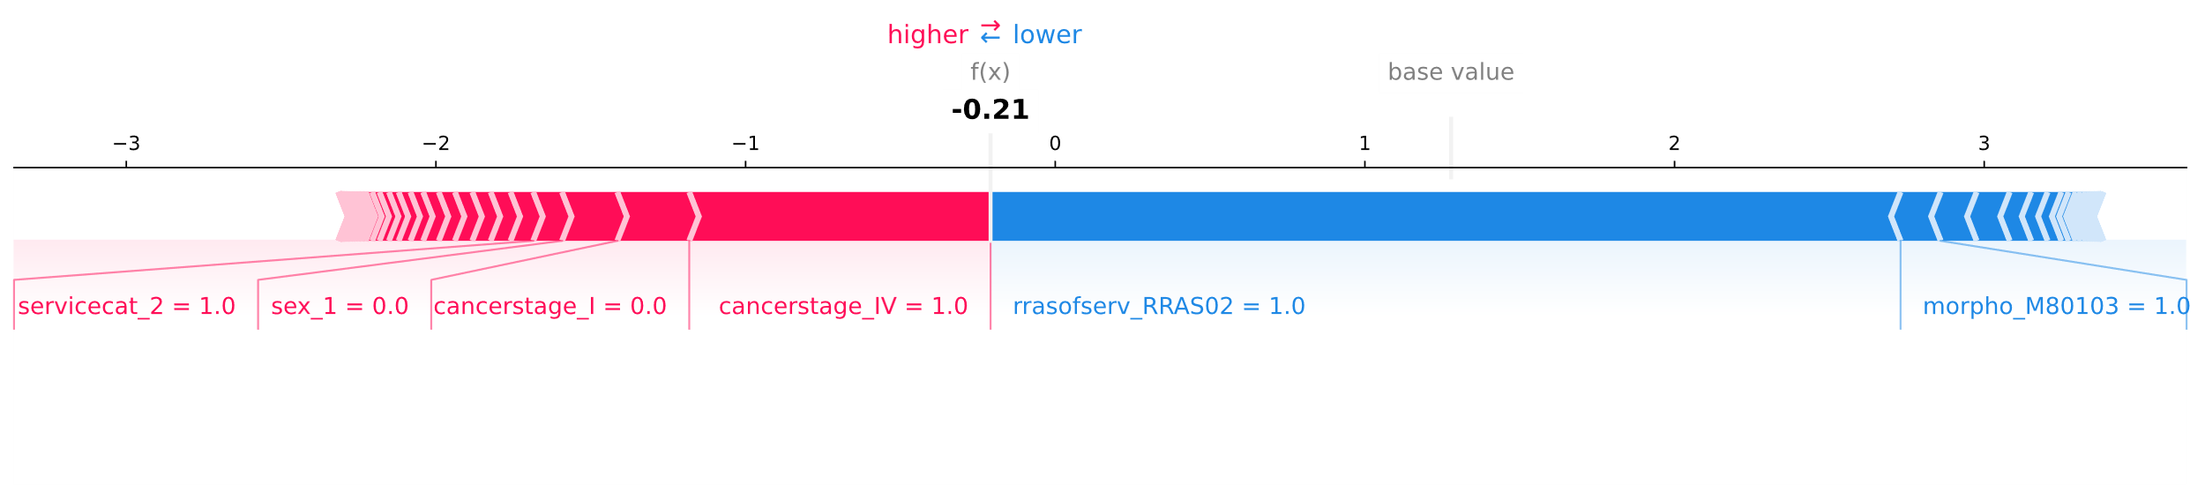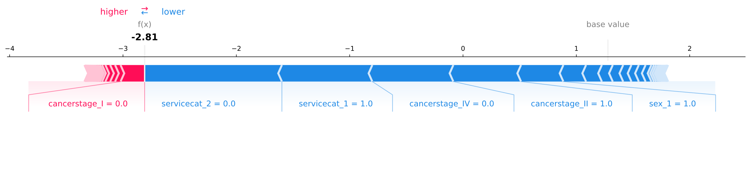

**a**

**b**

**c**

# **Figure A10. Top twenty predictors of risk of death from cancer 12 to 24 months after diagnosis. Model for colon cancer, with Catboost Classifier.**

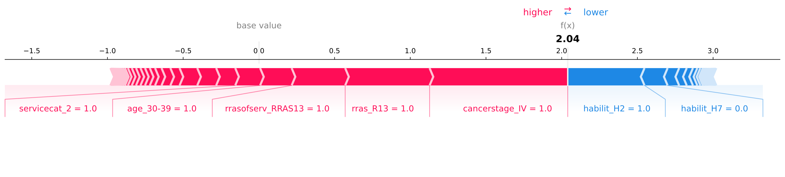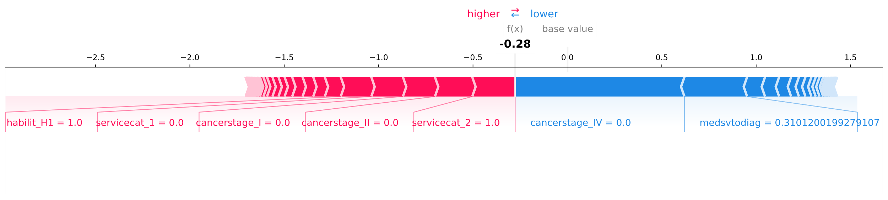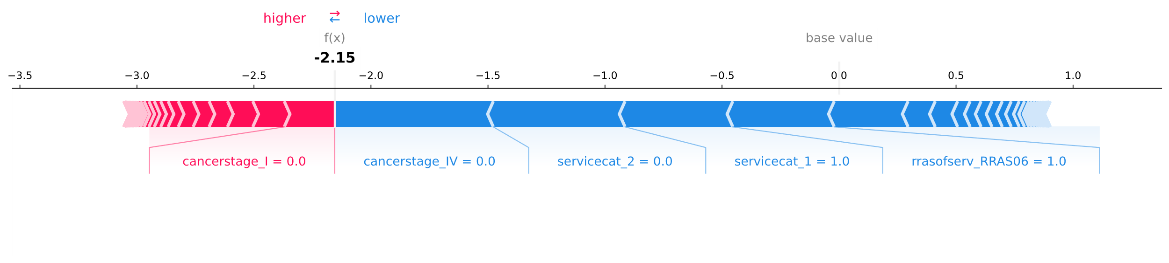

# **Figure A11. Main predictors of risk of death from cancer between 12 and 24 months after diagnosis for three randomly selected individuals: a) high risk of death (true positive with 0.885 score), b) medium risk of death (true negative with 0.431 score) and c) low risk of death (true negative with 0.104 score), model for colon cancer, with Catboost Classifier.**

**a**

**b**

**c**

# **Figure A12. Top twenty predictors of risk of death from cancer 12 to 24 months after diagnosis. Model for rectum cancer, with Catboost Classifier.**

# **Figure A13. Main predictors of risk of death from cancer between 12 and 24 months after diagnosis for three randomly selected individuals: a) high risk of death (true positive with 0.929 score), b) medium risk of death (false positive with 0.672 score) and c) low risk of death (true negative with 0.165 score), model for rectum cancer, with Catboost Classifier.**

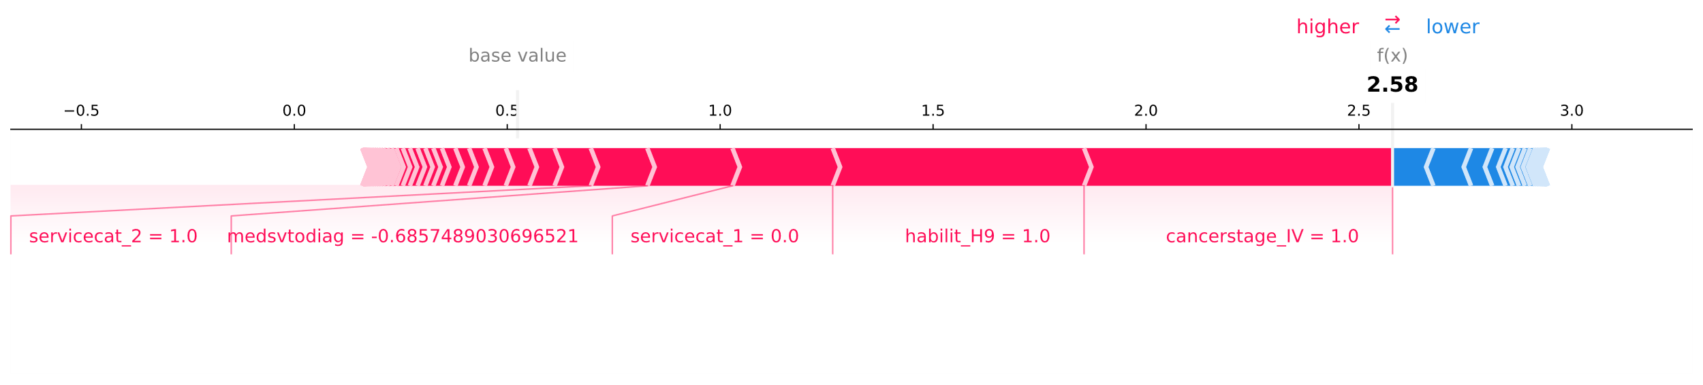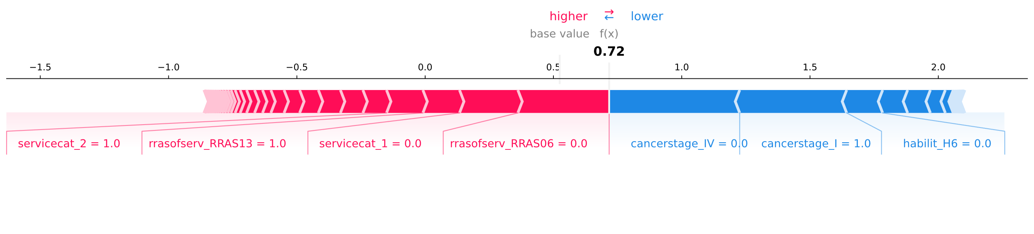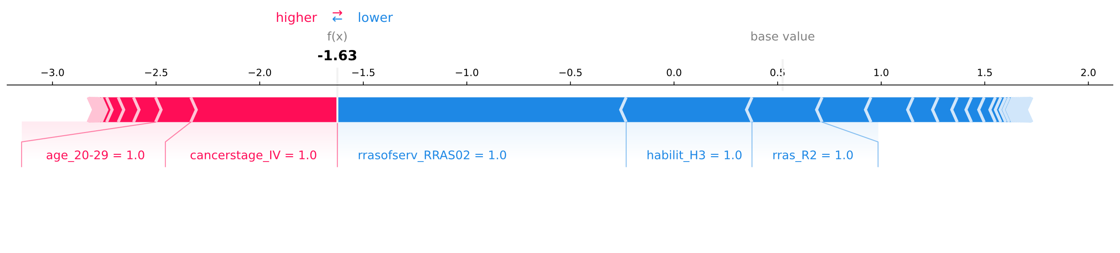

**a**

**b**

**c**

# **Figure A14. Top twenty predictors of risk of death from cancer 12 to 24 months after diagnosis. Model for prostate cancer, with Catboost Classifier.**

# **Figure A15. Main predictors of risk of death from cancer between 12 and 24 months after diagnosis for three randomly selected individuals: a) high risk of death (true positive with 0.707 score), b) medium risk of death (true positive with 0.560 score) and c) low risk of death (true negative with 0.033 score), model for prostate cancer, with Catboost Classifier.**

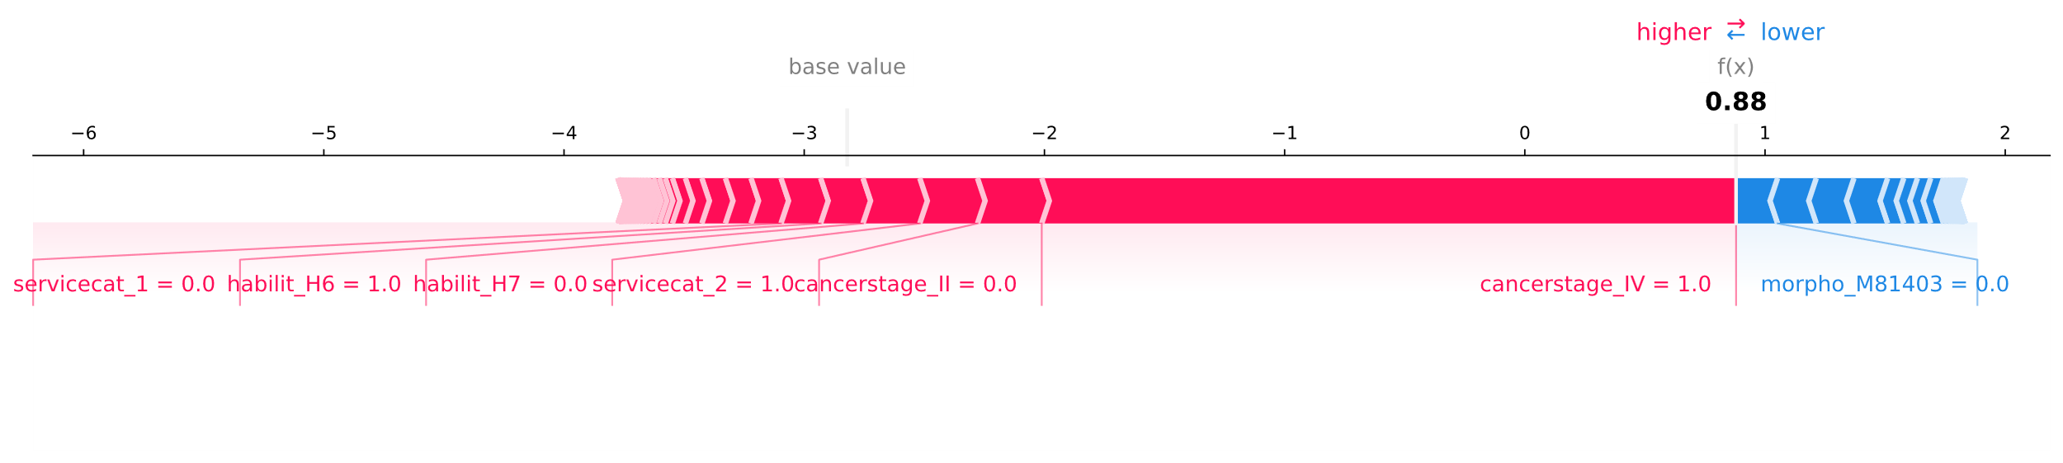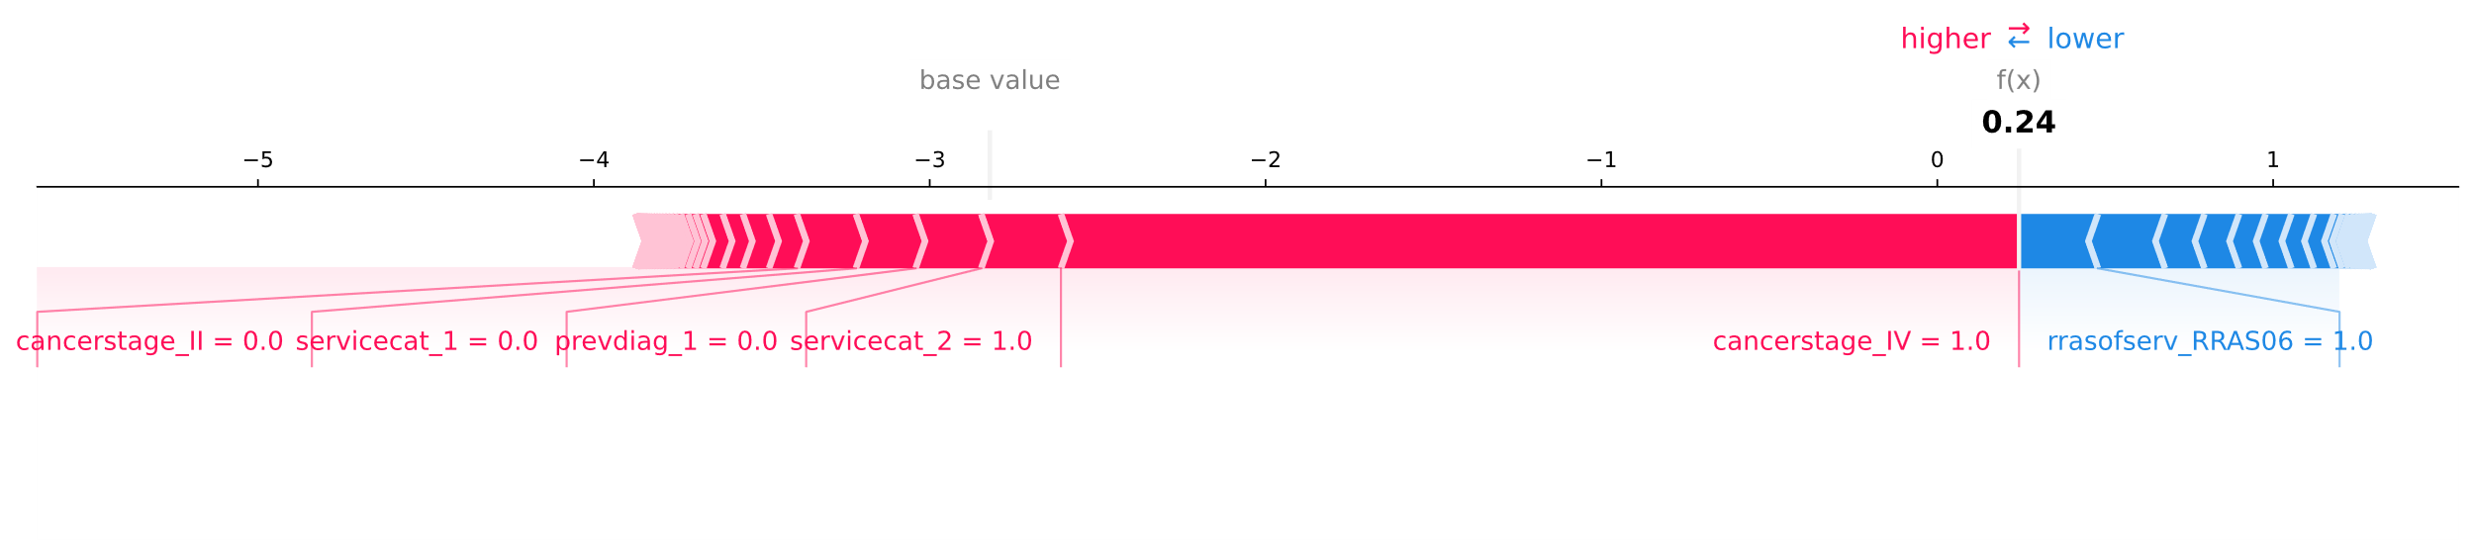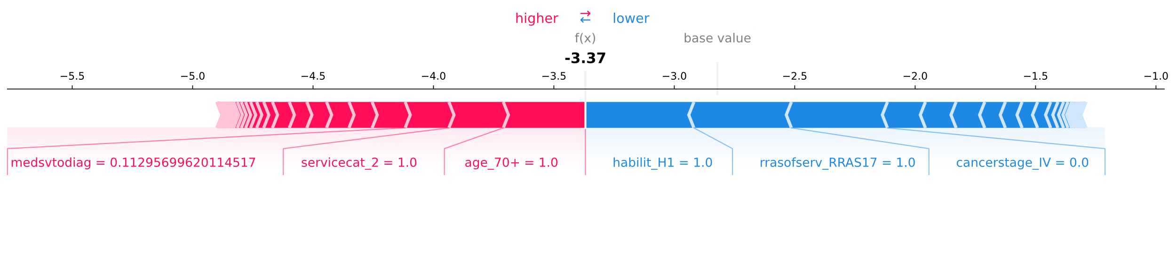

**a**

**b**

**c**

# **Figure A16. Top twenty predictors of risk of death from cancer 12 to 24 months after diagnosis. Model for cervix uteri cancer, with Catboost Classifier.**

# **Figure A17. Main predictors of risk of death from cancer between 12 and 24 months after diagnosis for three randomly selected individuals: a) high risk of death (true positive with 0.939 score), b) medium risk of death (true negative with 0.470 score) and c) low risk of death (true negative with 0.118 score), model for cervix uteri cancer, with Catboost Classifier.**

**a**

**b**

**c**

